HOW TO INSTALL THE SYSTEM

*download the system here <https://github.com/dpgamoso/gamoso_exam>

Click the code and download as zip

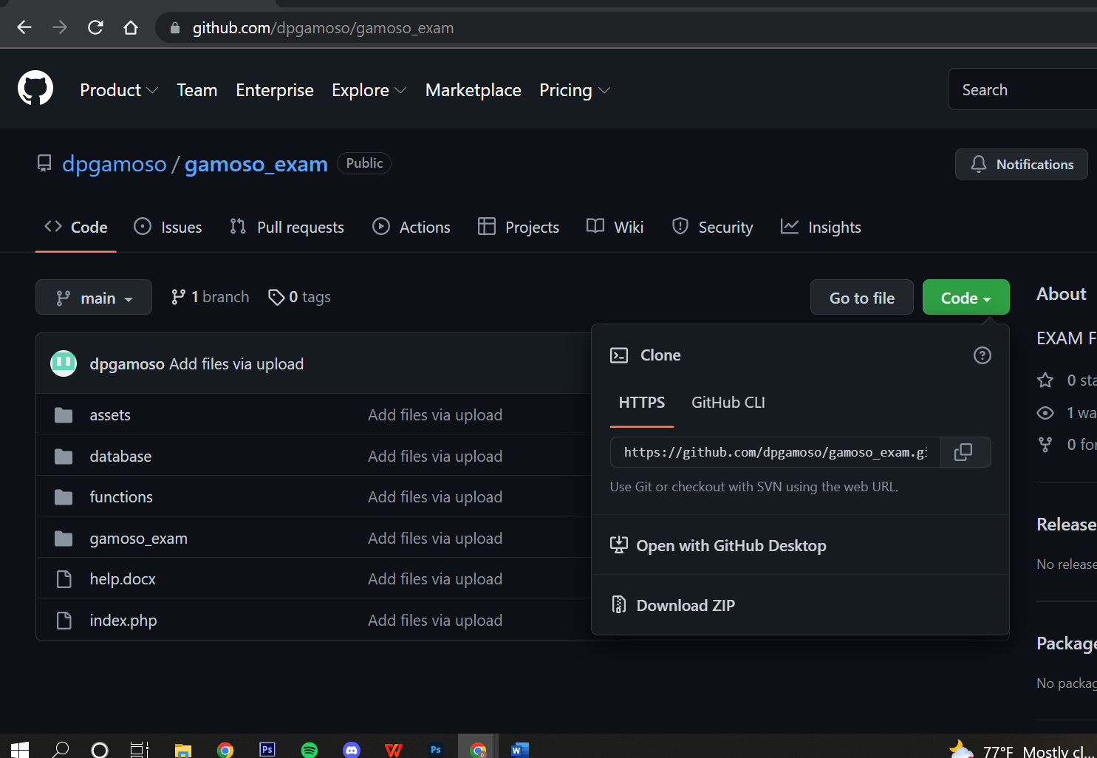

After downloading it you must extract it

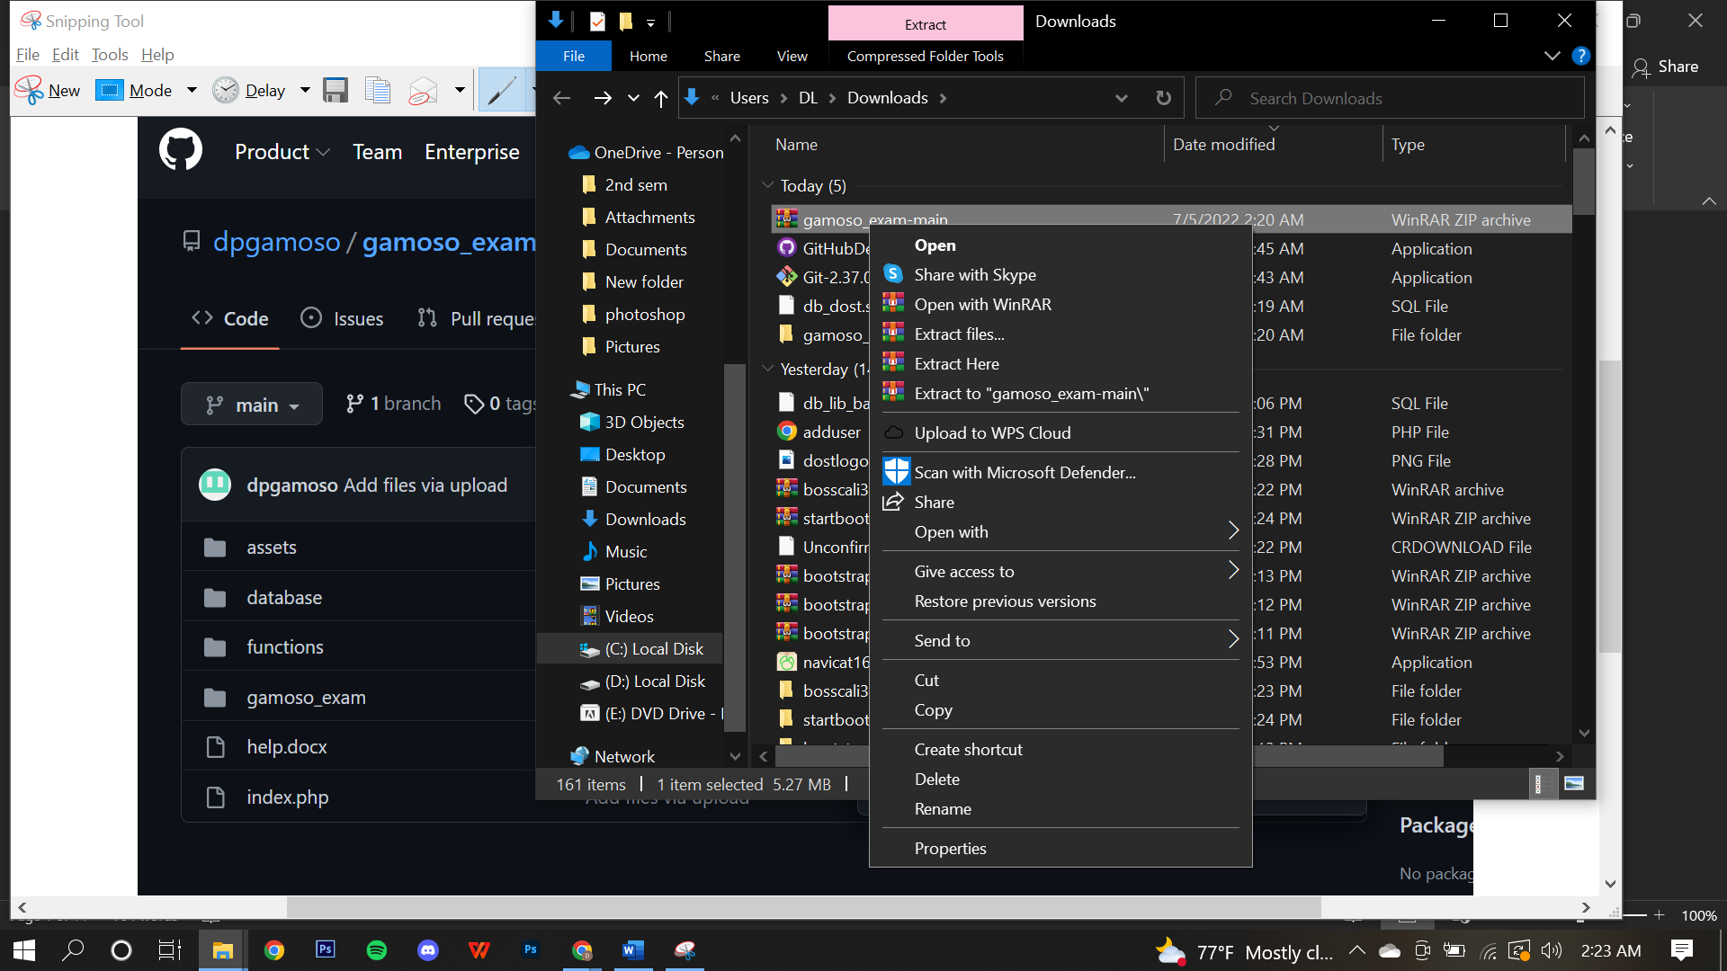

After extracting you will



Open it and you will see again a “gamoso_exam-main” folder

Now choose the second “gamoso_exam-main” and rename it to “gamoso_exam”

It should be like this… after that copy the gamoso_exam and paste to htdocs folder how to access htdoc folder is the next step

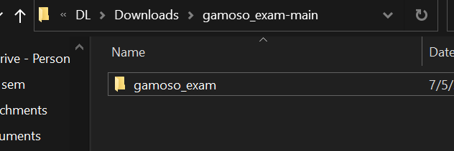

1.Download and Install XAMPP

Link: <https://www.apachefriends.org/download.html>

1. Click both Start ( Apache and MYSQL)

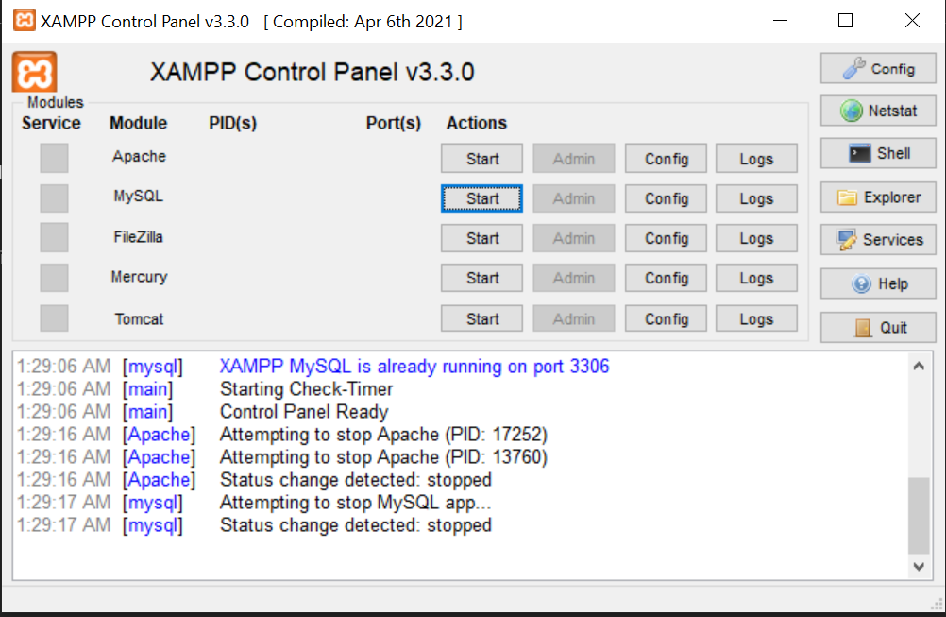

1. Also click explorer and you will be redirected xamp folder open htdocs folder and paste the project here name “gamoso_exam”

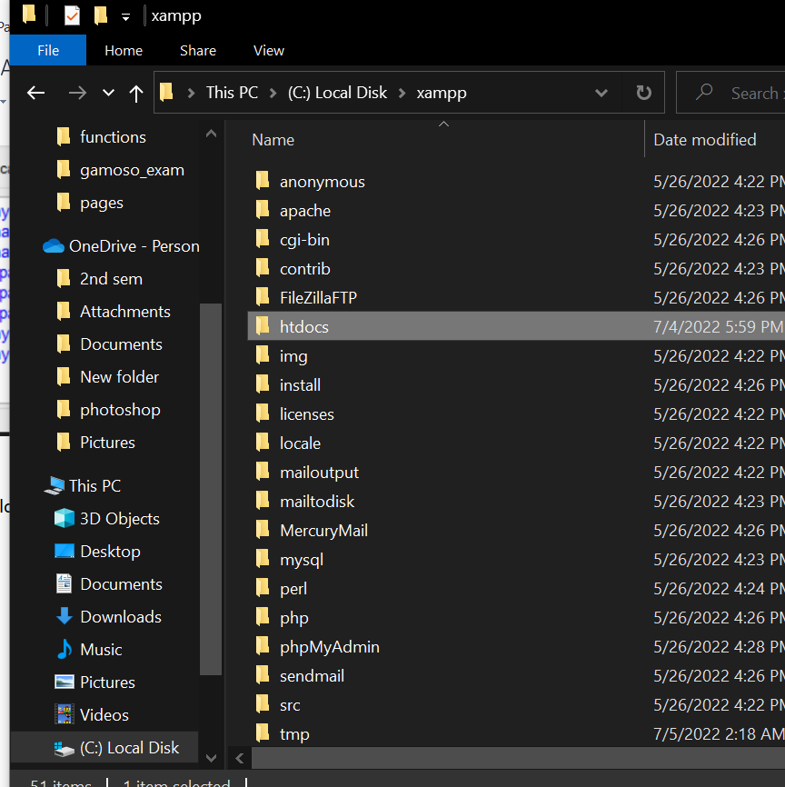

3. After clicking start open any browser and go to

Link: <http://localhost/phpmyadmin/>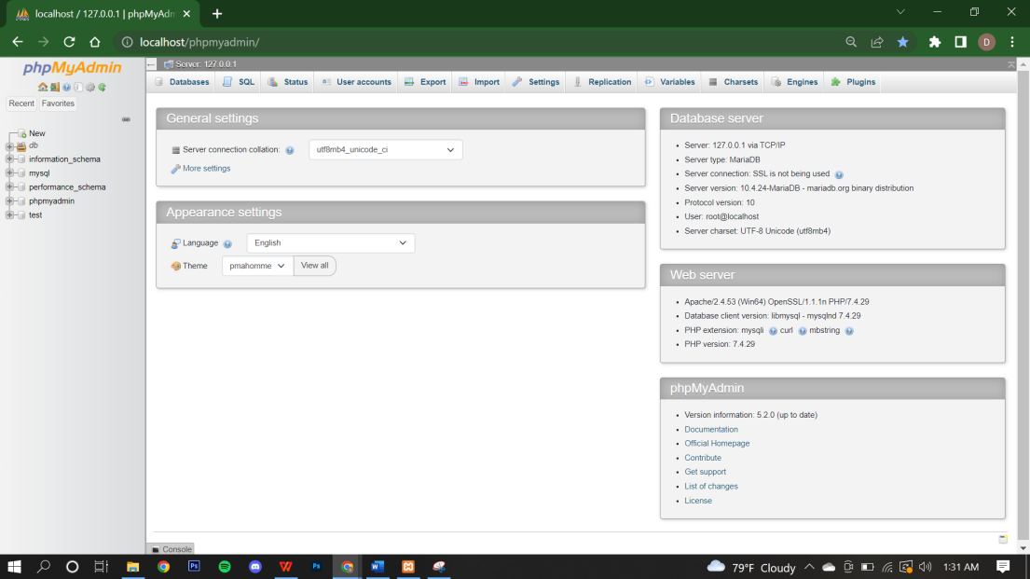

4. Click new

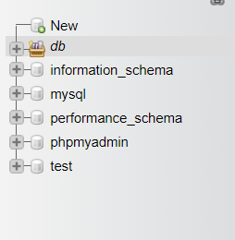

5. Create database with name “db_dost” then click create

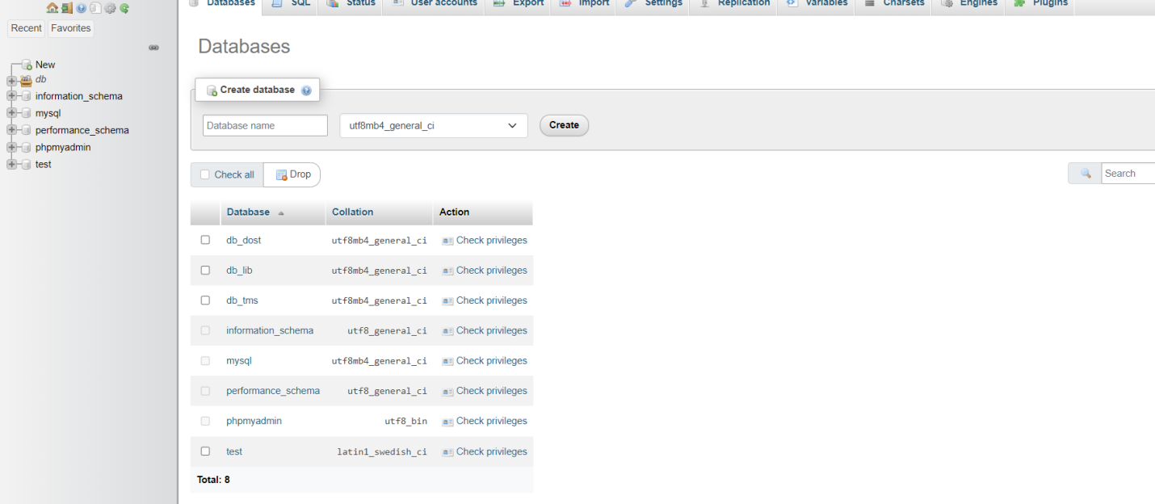

6. go to import

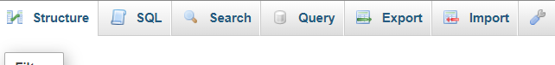

7. choose db_dost and click import

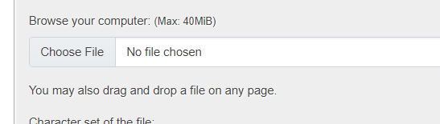

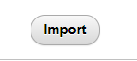

8. go to any browser and enter <http://localhost/gamoso_exam/index.php>

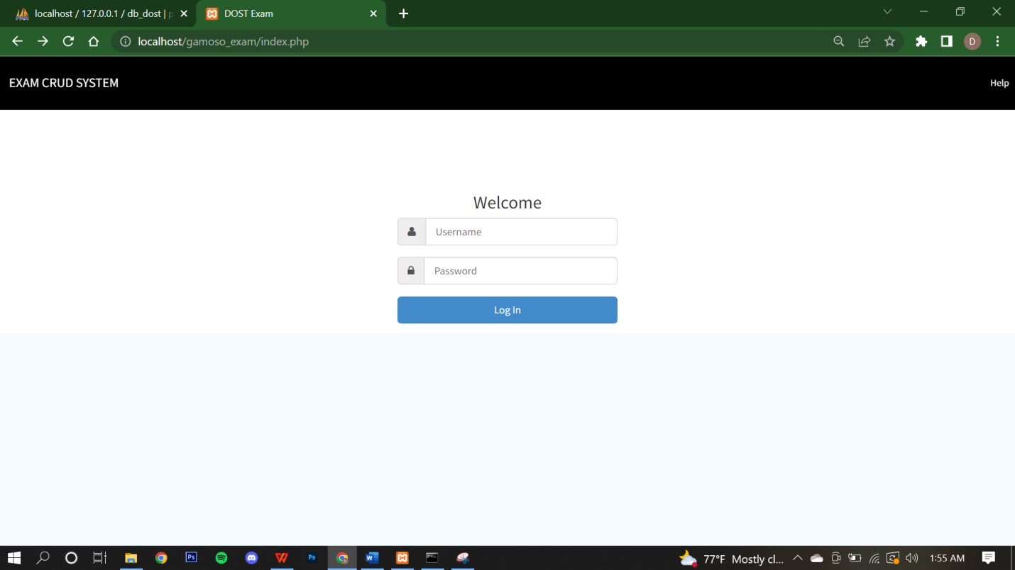

9. The Default account is

Username: admin

Password: admin

After logging in you will be directed here

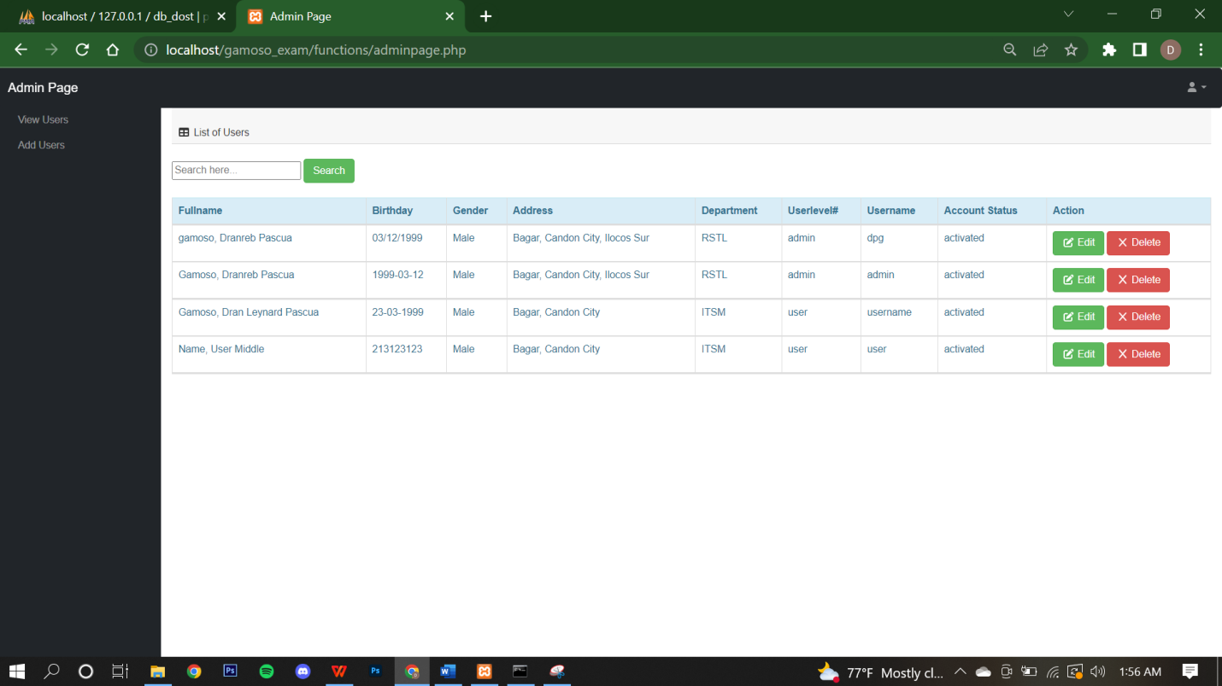

10. To add User click Add user

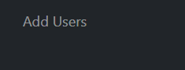

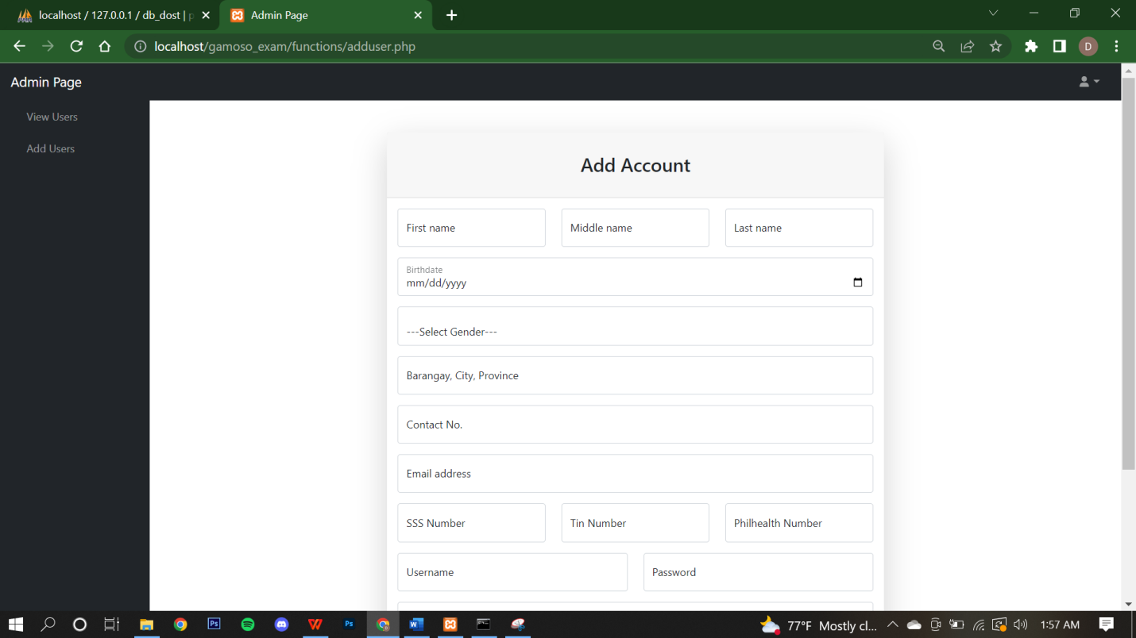

After adding you can go to View User update and delete.

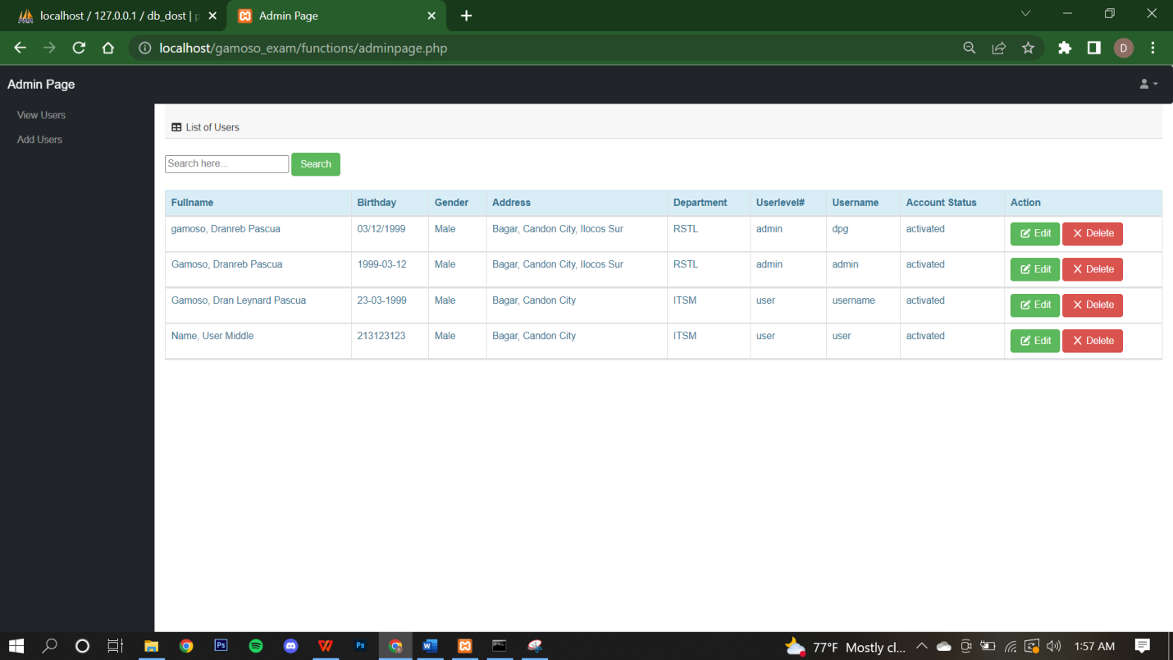

To Edit details just click the edit button of their names

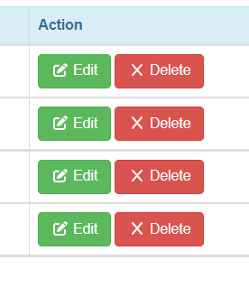

After click edit button you wil be going here.

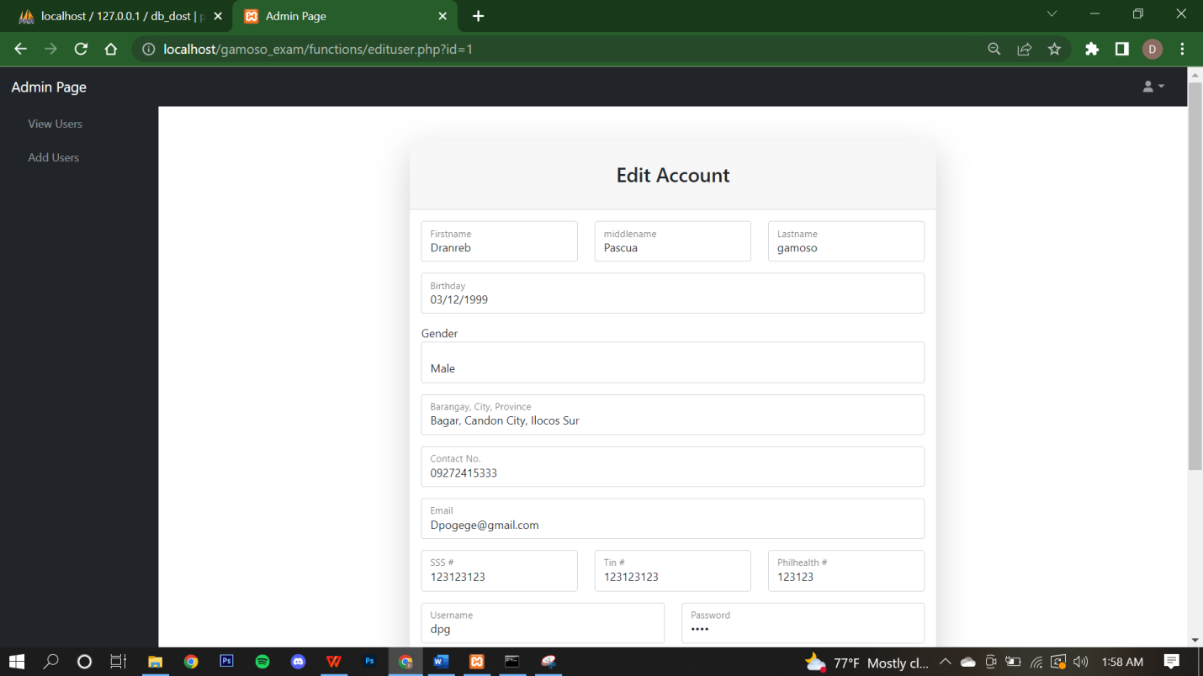

You can disable the users account thru changing user level to deactivated.

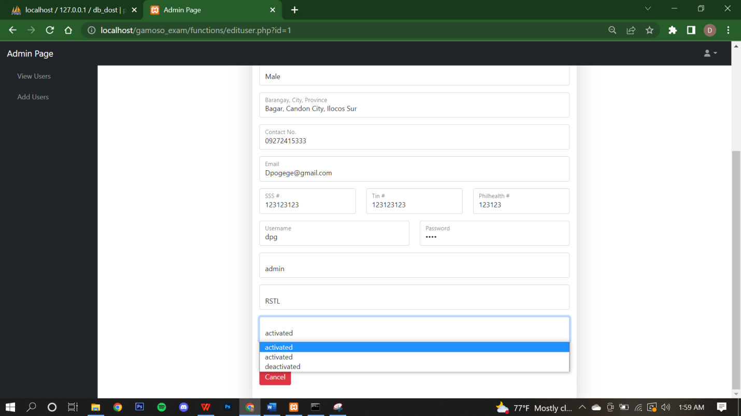

After that click Update

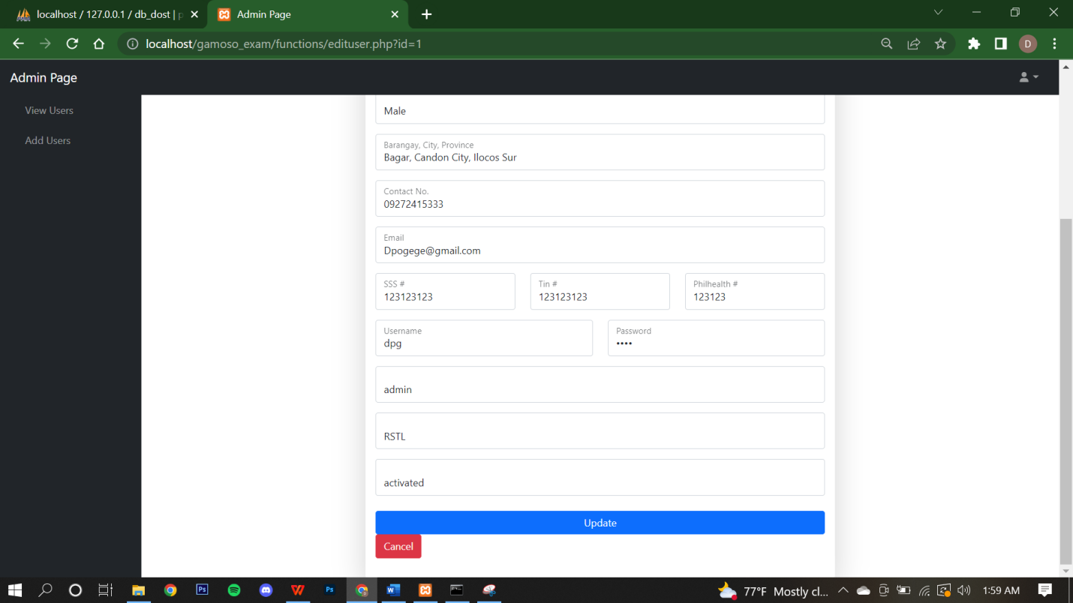

In userlevel user you can only edit some details.

